Circuit Design Assignment 1:

Printed Circuit Board Design

Assignment due Sunday at 11:59pm EST

# **1 Objectives**

PCB design is one of the most versatile skills used in the everyday lives of an electrical engineer. This assignment is meant to cement the skills needed to be a confident PCB designer and will take you through both the schematic capture and layout part of a PCB design.

# **2 Parts**

N/A, Just your laptops this week!

# **3 Pre-Lab**

# 3.1: Opamp Circuit

## 3.2.1: Gain Review

What is the gain of the following circuit? (Let’s say pin 2 is grounded, and pins 4 and 5 are pulled up to +/-5V respectively.) -1.643

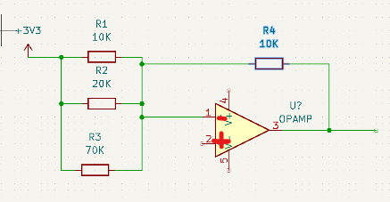

## 3.2.2: Identifying Components

Design an opamp circuit that will have an output of approximately 4.2V, given a supply voltage of 5V and input voltage of 3.3V. At this point a pen and paper schematic is fine. **Please include a picture of your schematic at this point here:**

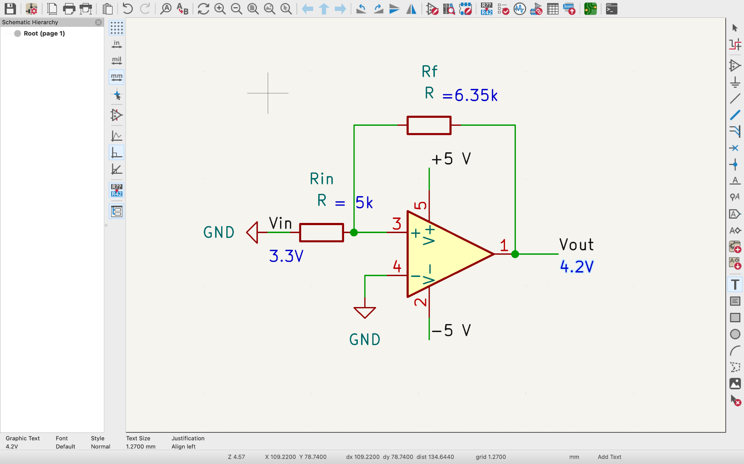

## 3.2.3: Design your Schematic

Let’s flesh this circuit out a little more. A good output indicator of whether your circuit is working is an LED, but you can’t just add an LED. You also have to add a resistor in series to make sure we don’t accidentally burn the LED. Please calculate the resistor value needed to dissipate the energy from a red LED (Ia= 10mA), where Vs=your output voltage, and N= number of LEDs you’re using, and Vled= 2V for a red LED.



**Resistor value= 220𝛀**

Now that you have this resistor and LED configuration, add it to the output of your schematic. **What does your schematic look like now?**

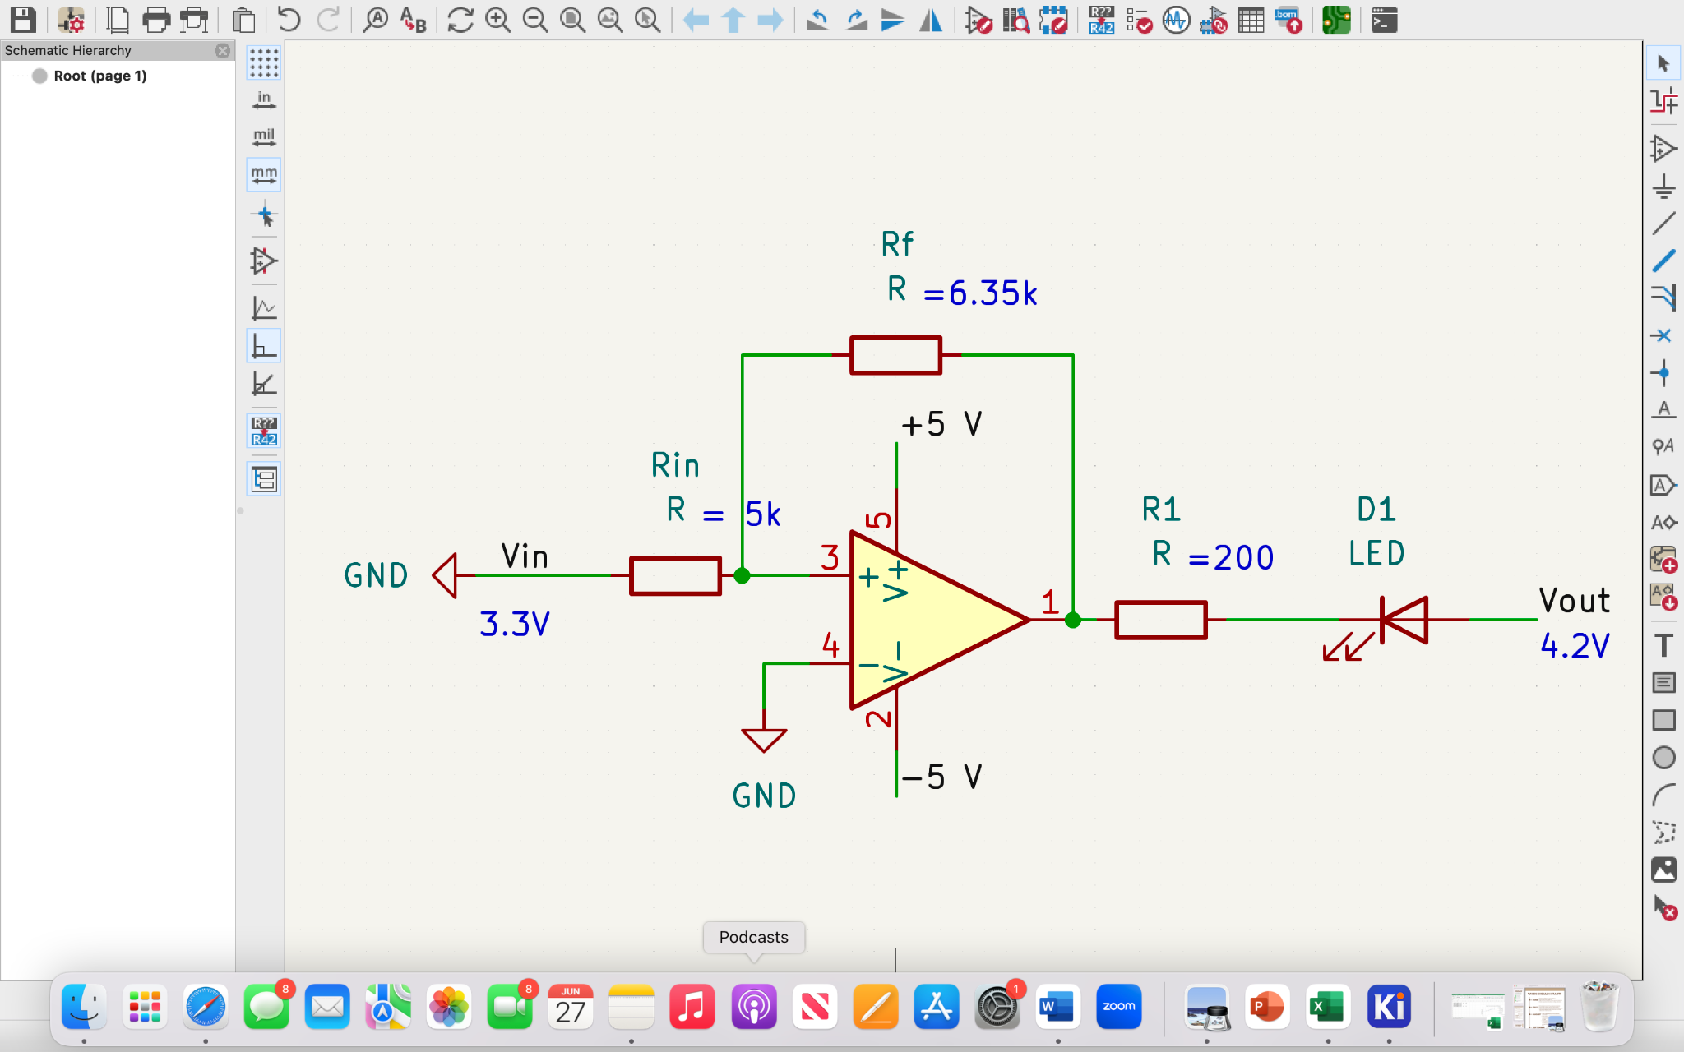

## 

# 

# **4 Lab**

# 4.1: Schematic Design

## 4.1.1: Place Components

It’s time to get into KiCad. First, start a new project. Then, in the schematic editor, you will need to find your IC’s and resistors. Please place each component that you believe you will need on your schematic. This can be accomplished by using the following buttons to place the corresponding components:

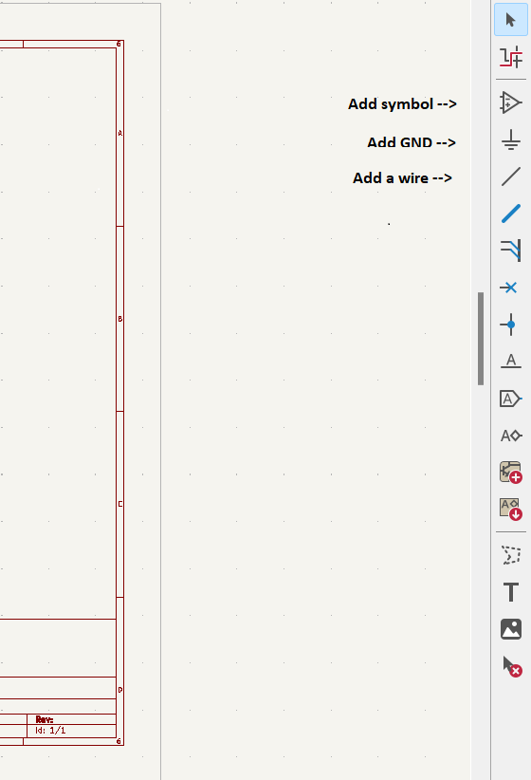

Additionally pressing the letter ‘P’ will allow for you to place a voltage source onto your schematic. Don’t forget your ground connections!

## 4.1.2: Finalize The Circuit

Now you should attach the components together by adding wires. This can be accomplished by clicking from bubble to bubble on the components or using the button in the previous picture that was labeled as ‘add a wire’ on your sidebar.

You will additionally need to place a connector in order to have a means for your tester to supply power and ground and make this a viable PCB. I recommend the component ‘Conn_01x02_Male’. Attach a power symbol to one point and a ground symbol to the other point.

You’re done on the schematic side! **Please screenshot the schematic design and include it below**

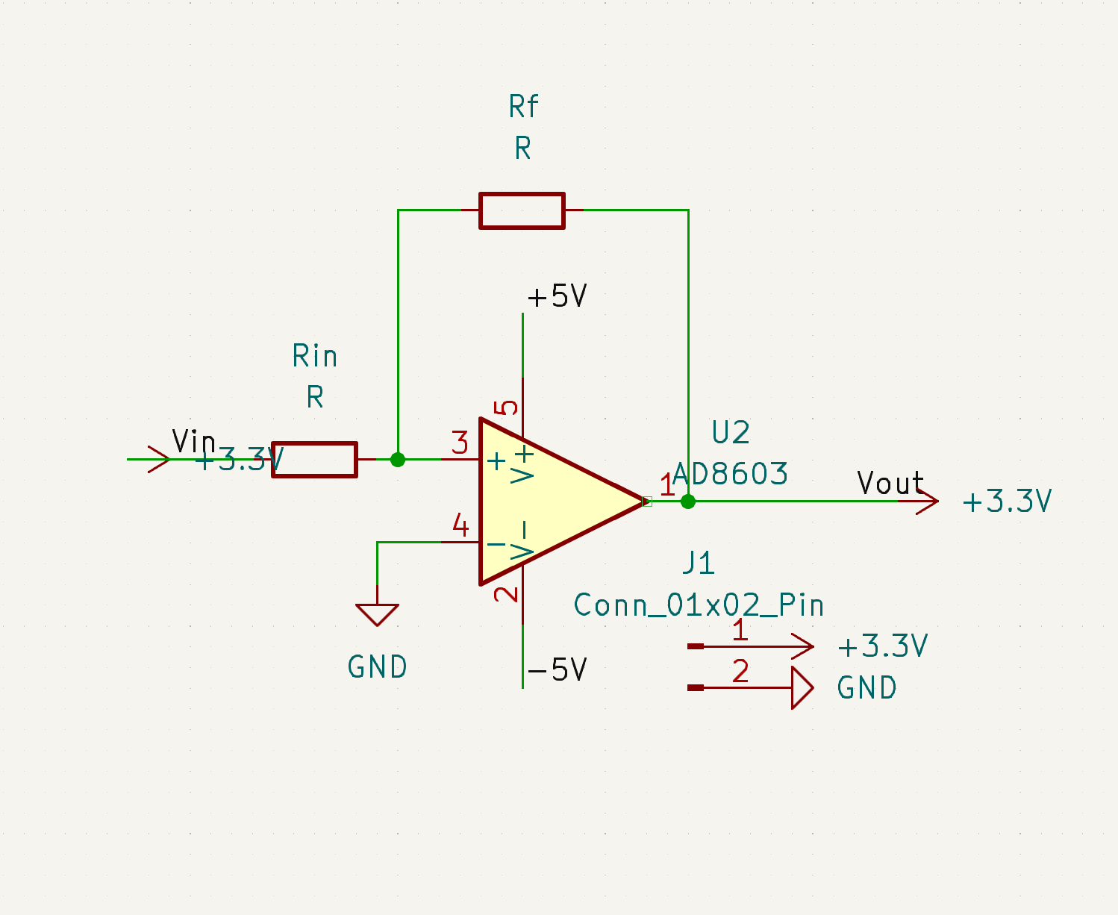

# 

# 4.2: Layout Design

## 4.2.1: Place your components

Now it’s time to import your schematic into the layout tool. This can be accomplished in the PCB editor by clicking Tools → ‘Update PCB from Schematic’.

Now go ahead and place components where you think they should go on the PCB. Note there’s no one ‘right’ answer. But making sure components are not overlapping, and traces (wires) are shorte is essential.

Now that you have the rough placements of components, modify your board shape to best fit your components. After all, the smaller the board, the cheaper it is to manufacture! Please **include a screenshot of your current board state here:**

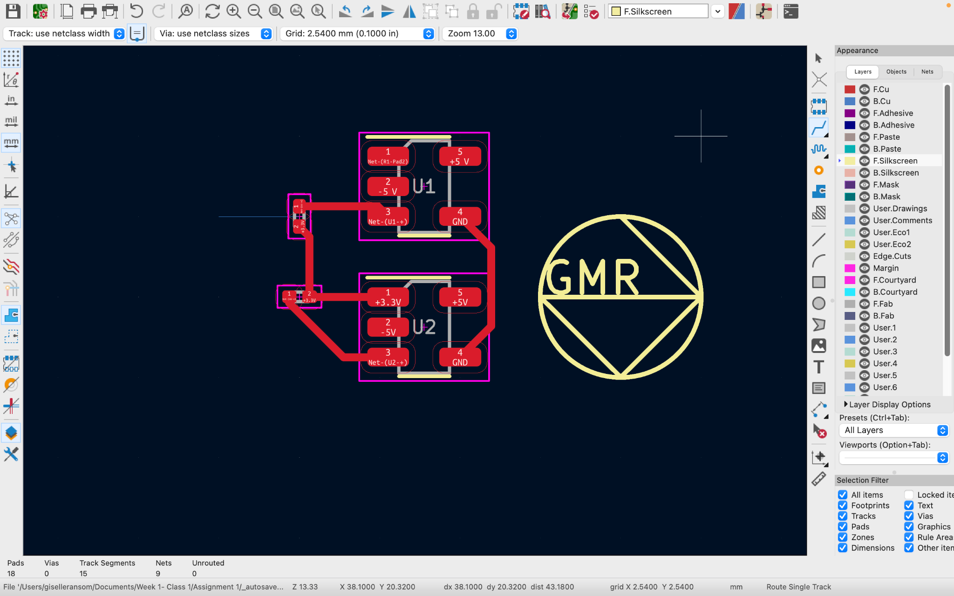

## 4.2.2: Connect your components

Now that your component places are determined it’s time to wire the parts together using the create trace button in Kicad. Make sure to connect each component correctly by matching the names of each ‘net’ together. Make sure especially to confirm that all power and ground lines are connected not only to each other, but to your power connector as well. Feel free to use vias and route on the bottom layer if needed.

**What trace thickness did you use?** The smaller the trace, the easier it is to connect everything. However, if your trace is too small your current might be limited (since if you have a small wire current can’t pass through it as easily).

The most essential part to a good PCB design is having a fun silkscreen (a picture that’s generally informative or fun, your choice!). Make sure to add a unique silkscreen to your PCB using the following tutorial: <https://community.element14.com/members-area/b/blog/posts/kicad-6---adding-logos-and-graphics-to-a-silkscreen> .

**Please take a screenshot** of the board in both 2D and 3D modes and include them below:

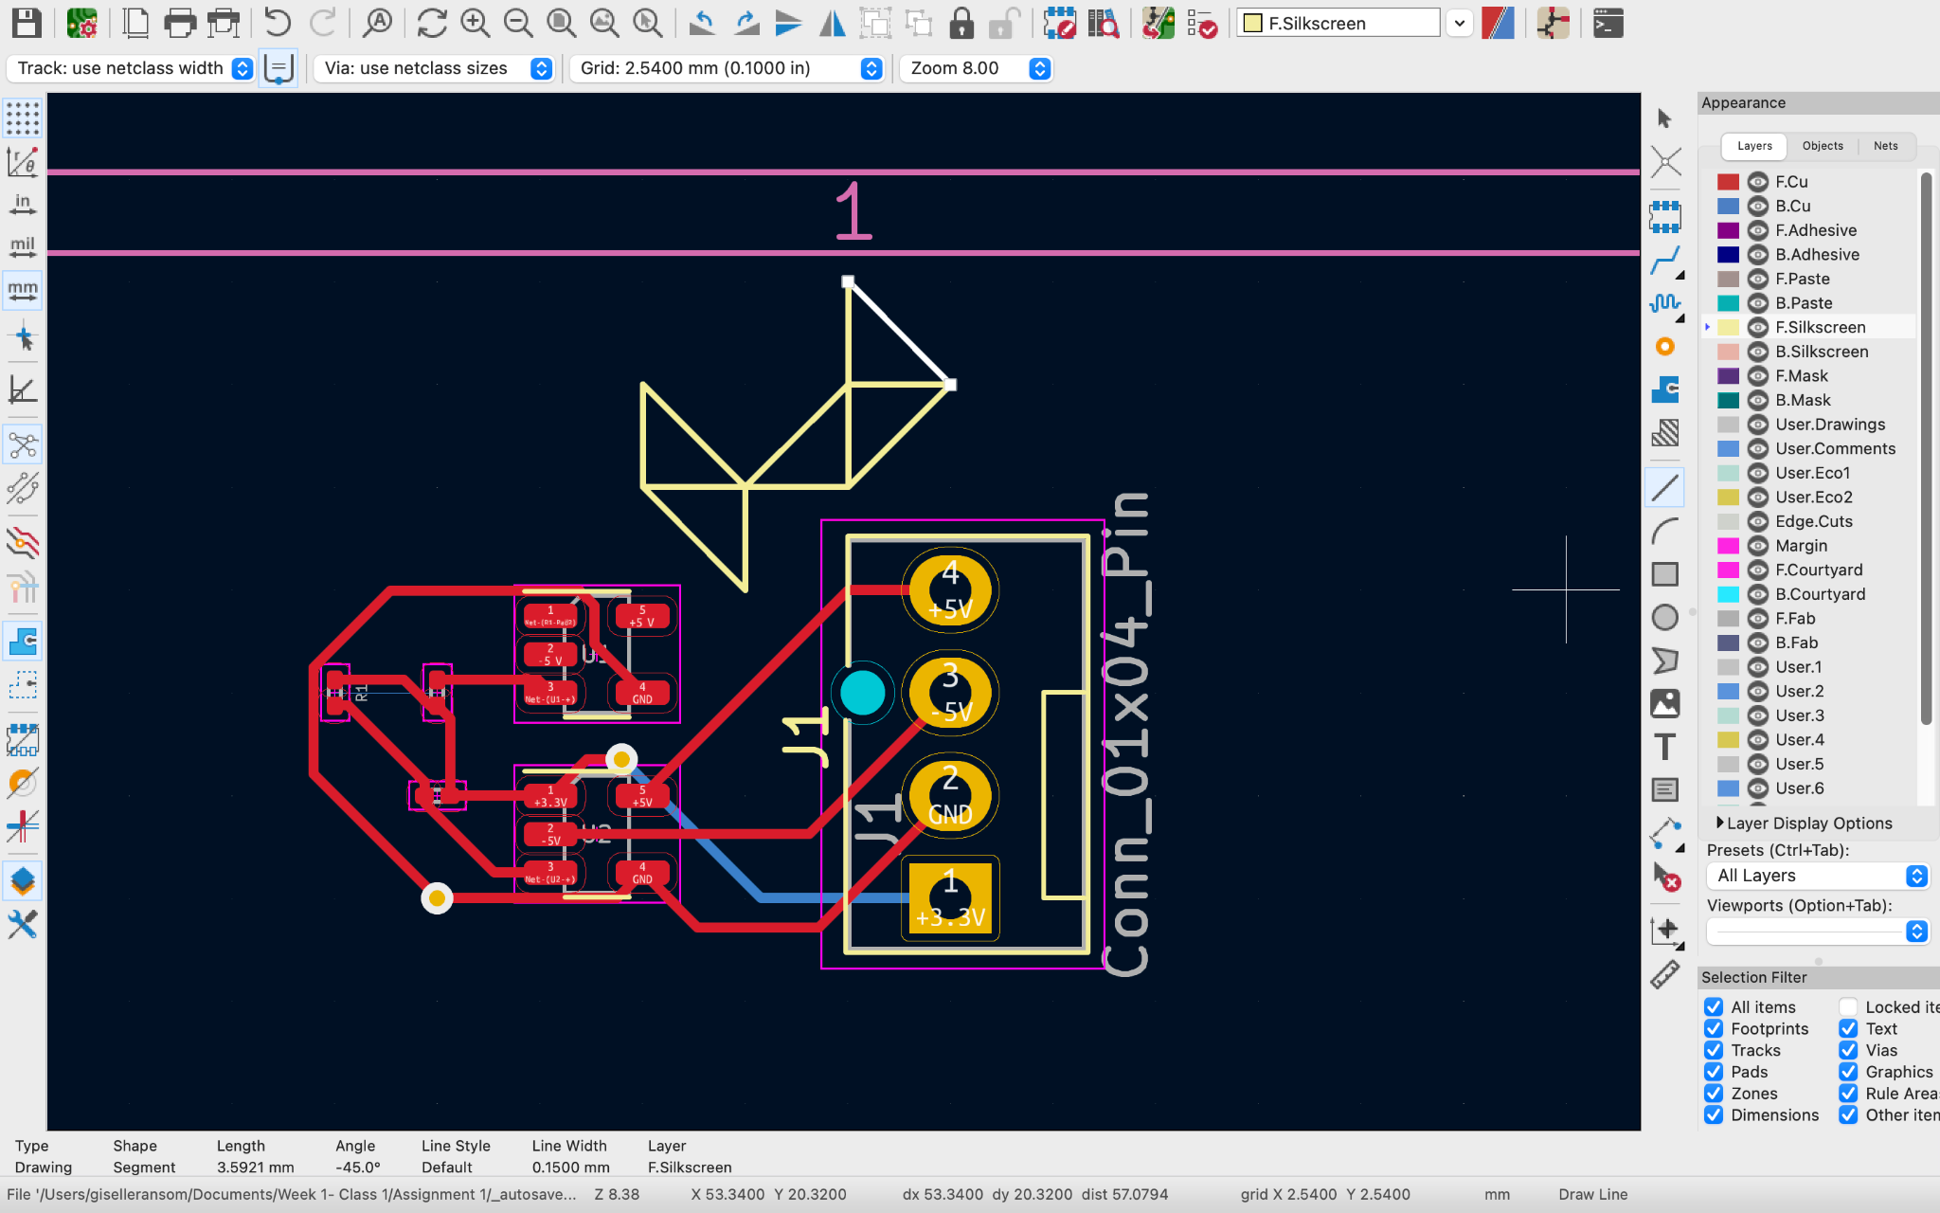

# 

# 

# **5 Reflection**

Individually, answer the questions below. Two to four sentences for each question is sufficient. Answers that demonstrate little thought or effort will not receive credit!

# 5.1: What was the most valuable thing you learned, and why?

The most valuable thing I learned was how op-amps work by converting the frequency of the in voltage. At first I was very confused, but I eventually got the hang of it and was able to truly test my critical thinking.

5.2: What skills or concepts are you still struggling with? What will you do to learn or practice these concepts?

I am struggling with understanding how PCB works and how to properly connect all of the parts. In order to learn the concept I plan on spending extra time in Kicad and watching instructional videos.